“I can do everything through Him who gives me strength.” -- Philippians 4:13
- Please show all your work! No partial credit will be given for incorrect answers with no work shown. Please draw a box around your final answer.
- Calculators are permitted, but no notes, text, laptops, PDAs, or electronic dictionaries. Cell phones should be muted and left in your pocket or bag.
- Table 3 is attached to the back. You may detach it for your reference.
Total marks: 70

- Mark each of the following variables as categorical (G) (not ordinal), ordinal (O), discrete (D), or continuous (C). [5]
  - Blood glucose level in mmol/L: Continuous
  - Which bone a patient fractured (tibia, ulna, rib, etc.): Categorical
  - Number of visits a student has made to the Wellness Centre: Discrete
  - Whether a person likes pineapple (i.e., true/false) Categorical
  - The final letter grade for a course at TWU: Ordinal
- Mark each of the following statements as descriptive (D) or inferential (I). [4]
  - 20% of volleyball players injure their knees in their first two years. Inferential
  - In 2006, 16% of players on TWU’s women’s volleyball teams
injured their knees. Descriptive
  - Half of all women will contract heart disease in their lifetime. Inferential
  - Smoking increases the chance of lung cancer by threefold. Inferential
- Assume that a population of 200 people has normally-distributed body mass index (BMI), with mean 24 and standard deviation 2.5. How many of the 200 people are classified as overweight, with a BMI between 25 and 30? [4]
~33.64%
- Give an example of a pair of events that are independent. Be sure to define each event clearly. Also define the total sample space. [3]
There are many possible answers; a simple one is flipping a coin multiple times: the event “heads on first flip” is independent of the event “heads on second flip”. The whole sample space is { (H,H), (H,T), (T,H), (T,T) }.
- Assume the list below represents the raw data for an experiment measuring the lecithin concentration in active muscles. Draw an (absolute) frequency histogram, classifying the data by μmol/g. [4]
4.8 μM/g | 5.1 μM/g | 5.2 μM/g
5.2 μM/g | 5.5 μM/g | 5.8 μM/g
6.1 μM/g | 6.4 μM/g | 7.2 μM/g
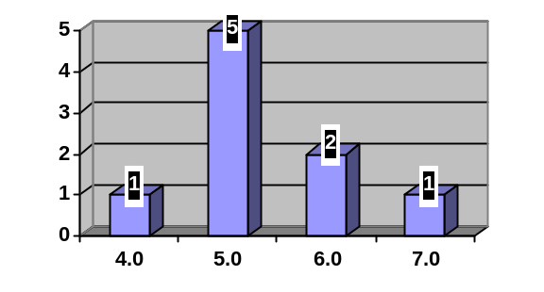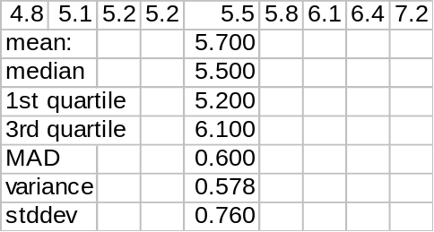
  - Calculate the mean lecithin concentration for the sample. Please show your work. [2]
5.7
  - Calculate the standard deviation of the lecithin concentration in the sample. Please show your work. [5]
~0.76
  - Draw a boxplot for the data. Show all your work. [5]
min = 4.8
1st = 5.2
med = 5.5
3rd = 6.1
max = 7.2
  - If another patient was added to the sample with a very high lecithin concentration of 8.8 μM/g, would you expect the mean or the median to be more robust (resistant) to the outlier? [2]
Median is more robust
- A pharmaceutical company has devised a test for Alzheimer’s disease. Assume that if a person has Alzheimer’s, the test has a 70% chance of detecting it (70% sensitivity). Assume that if a person does not have Alzheimer’s, the test has a 8% chance of giving a false positive (92% specificity).
  - Suppose 200 people use the test, and that 40 of those people really have Alzheimer’s. Draw an event tree for the outcomes of the test, and label the tree with probabilities for each branch of the tree. [5]
Alzheimer’s: 20%
No Alzheimer’s: 80%
Test +: 70%
Test -: 30%
Test +: 8%
Test -: 92%
  - What is the probability that a randomly chosen person from this group will test positive for Alzheimer’s? [3]
(.20)(.70) + (.80)(.08) = 20.4%
  - Suppose that a randomly chosen person from this group does test positive. What is the probability that this person really has Alzheimer’s? [2]
(.20)(.70) / .204 =~ 68.63%
- The weight of a population of 1-year-old boys is normally distributed with mean 25lbs and standard deviation 1.2lbs.
  - A particular baby boy weighs 26.356 lbs. What percentile does his weight rank on the growth chart? [3]
87.08th percentile
  - What is the 10th percentile weight? [3]
~23.464 lbs
  - What is the probability that the weight of a baby boy in this population is within one pound of the mean? [3]
~59.34%
- Let A represent marathon runners. Let B represent people with heart disease. Translate each of the following statements into probability notation using A and B, and draw a Venn diagram in the box provided, shading in the region described. (If it’s a conditional probability, write “not applicable” in the Venn diagram.)
  - Half of the people in this study are runners. [3]
P(A) = 0.50
A
  - 5% of the runners in this study have heart disease. [3]
P(B|A) = 0.05 (Venn diagram not applicable)
B
  - In this study, for every person who has heart disease, there are 19 others who do not have heart disease. [3]
P(B) = 0.05
B
  - What is the probability that someone in this study is a runner with heart disease? [2]
P(A and B) = P(B|A) P(A) = (0.05)(0.50) = 2.5%
  - What fraction of the people in this study neither run nor have heart disease? [3]
P( (A and B)^{C} ) = 1 – P(A) – P(B) + P(A and B)
= 100% - 50% - 5% + 2.5%
= 47.5%
  - In this study, is running independent of heart disease? Why? [3]
Yes: P(B|A) = 5% is the same as P(B) = 5%.
The chance of heart disease is the same regardless of if they run (in this study).

